5/27/2018
MyMart
Your own shopping center

Overview of Company and Product(s)

Deepak Kumar
c0738184

Navleen Kaur
c0735885

Hardeep Kaur
c0738253

My MART

Short description
MyMART is a retailer shopping mall in which customer will get different types of goods which could be used for daily purposes at wholes ale cost.

Products Overview: -

In MyMart will contain different variety of products, which will categories as following
Department> Category> Product
So due to that description of every product in MyMART will vary as per its categorization. For product description you may follows the given following table, from which you may get that which type of information will be store in our database:

Customer Sales Invoice

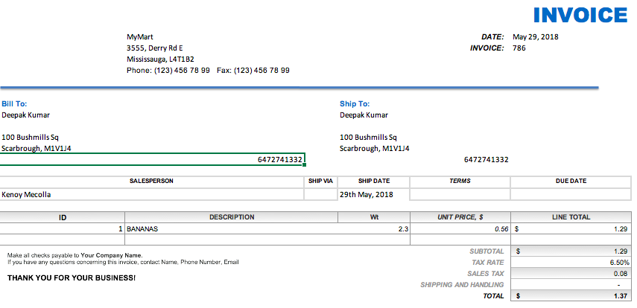

Entity & Attribute Identification
Product
Prodcut_ID | Decription | Quantity / weight(wt) | Unit Price | Line Total

Order
Order_Id. | Date | Order_desc | Cust_Id

Customer
Cust_id | cust_name | cust_phone | cust_Address

Order_Line
id | product_id | Quantity / weight(wt) | Invoice_No.

Conceptual Design

ER Diagram

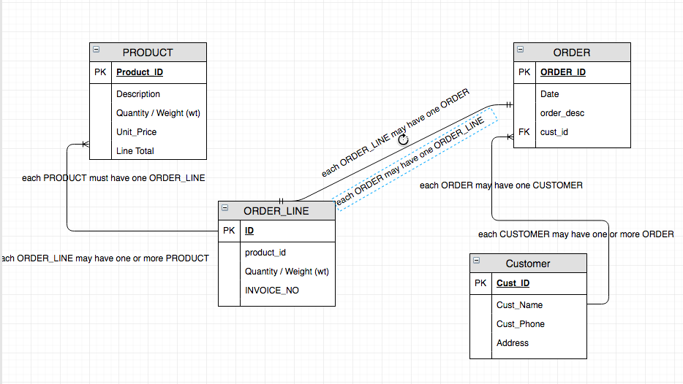

Logical Model

1. Normalized table in 3NF
Product
Prodcut_ID | Decription | Quantity / weight(wt) | Unit Price | Line Total

Order
Order_Id. | Date | Order_desc | Cust_Id

Customer
Cust_id | cust_name | cust_phone | cust_Address

Order_Line
id | product_id | Quantity / weight(wt) | Invoice_No.

2. Relational Schema

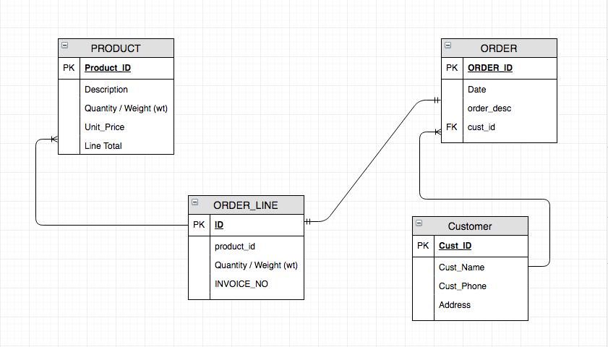

Physical Model
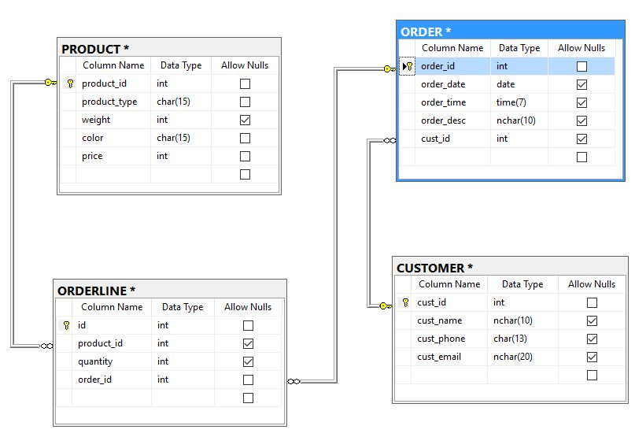

Implementation of Physical Model
1. Construct CREATE statements for each table

CREATE TABLE CUSTOMER( cust_id int NOT NULL,
cust_name nvarchar(30) NOT NULL,
cust_phone nvarchar(12) NOT NULL,
cust_email nvarchar(30) NOT NULL);

CREATE TABLE "ORDER"( order_id int NOT NULL,
order_date date NOT NULL,
order_time time NOT NULL,
order_desc nvarchar(50) NULL,
cust_id int NOT NULL);

CREATE TABLE ORDERLINE( id int NOT NULL,
product_id int NOT NULL,
quantity INTEGER NOT NULL,
order_id int NOT NULL);

CREATE TABLE PRODUCT( product_id int NOT NULL,
product_type nvarchar(30) NOT NULL,
weight float NOT NULL,
color nchar(20) NULL,
price bigint NOT NULL);

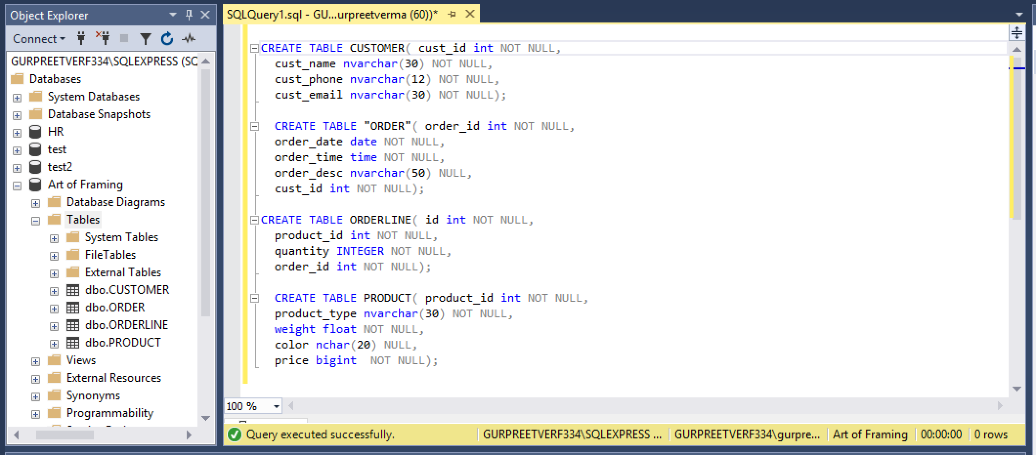

2. Construct INSERT statements and populate each table with at least 10 rows:

Populating PRODUCT Table

INSERT into PRODUCT (product_id,product_type,weight,color,price)
VALUES
(64,'Picture',1060,'Brown',99),
(65,'Mirror',1000,'White',120),
(66,'Canvas',1500,'Black',150),
(67,'Mirror',700,'Brown',30),
(68,'Mirror',960,'Brown',25),
(69,'Canvas',600,'Brown',20),
(70,'Mirror',1600,'Brown',150),
(71,'Canvas',1600,'Brown',150),
(72,'Mirror',1200,'Brown',120),
(73,'Canvas',1600,'Brown',150),
(74,'Canvas',1300,'Silver',120);

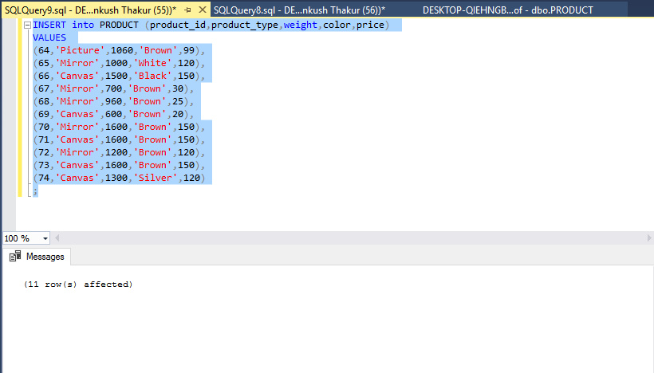

Populating CUSTOMER Table

INSERT into CUSTOMER(cust_id,cust_name,cust_phone,cust_email)
VALUES
(2,'RUDY',647888899,'rudy@example.com'),
(3,'Micheal',416889988,'micheal@example.com'),
(4,'Brein',4378899552,'brein@example.com'),
(5,'Victoria',8955454888,'vict@example.com'),
(6,'Emily',6478855699,'eli@example.com'),
(7,'Watson',89625555,'wat@example.com'),
(8,'Zafar',125555558,'zaf@example.com'),
(9,'Jack',4165828999,'jack@example.com'),
(10,'Danial',415695224,'den@example.com'),
(11,'Bucky',955628852,'bucky@example.com')
;
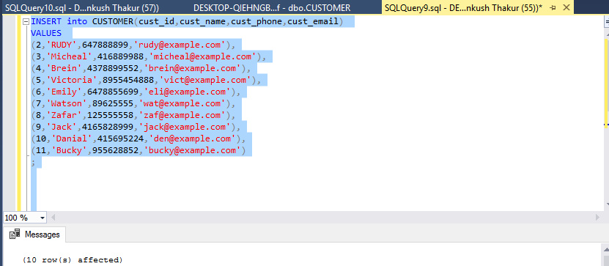

Populating ORDERLINE Table

INSERT into ORDERLINE (id,product_id,quantity,order_id)
VALUES
(1002,'55',1,5002),
(1003,'58',2,5003),
(1004,'60',1,5004),
(1005,'61',1,5005),
(1006,'55',1,5006),
(1007,'57',1,5007),
(1008,'59',1,5008),
(1009,'56',1,5009),
(1010,'59',1,5010),
(1011,'55',1,5011)
;
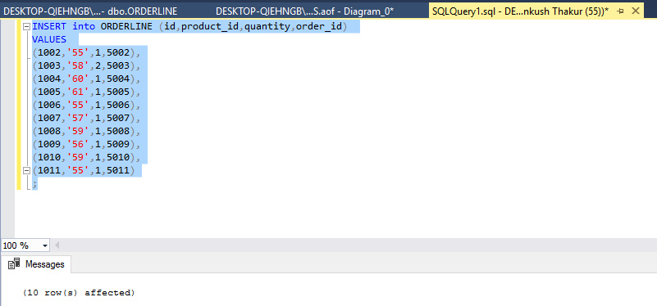
Identifcation of Bussiness rules

1. Business rules list applicable on respective columns which are described below.

NOT NULL Constraints
cust_id NOT NULL
cust_name NOT NULL
cust_phone NOT NULL
cust_email NOT NULL
order_id NOT NULL
order_date NOT NULL
order_time NOT NULL
order_desc NULL
cust_id NOT NULL
id NOT NULL
product_id NOT NULL
quantity NOT NULL
order_id NOT NULL
product_id NOT NULL
product_type NOT NULL
weight NOT NULL
price NOT NULL

Primary Key Constraints
cust_id
order_id
product_id
id

Unique key Constraints
cust_phone
cust_email

Foreign Key Constraints
cust_id in Table ORDER
product_id and order_id in Table ORDERLINE

Check Constraints
quantity (check it's value must be 1 in Table ORDERLINE)

1.a. List of constraints which are must to programmed in database.

Primary Key Constraints
cust_id
order_id
product_id
id
Check Constraints
quantity (check it's value must be 1 in Table ORDERLINE)

NOT NULL Constraints
cust_id NOT NULL
cust_name NOT NULL
cust_phone NOT NULL
cust_email NOT NULL
order_id NOT NULL
order_date NOT NULL
order_time NOT NULL
order_desc NULL
cust_id NOT NULL
id NOT NULL
product_id NOT NULL
quantity NOT NULL
order_id NOT NULL
product_id NOT NULL
product_type NOT NULL
weight NOT NULL
price NOT NULL

Foreign Key Constraints
cust_id in Table ORDER
product_id and order_id in Table ORDERLINE

2. Implementation of constraints in database.

Primary Key Constraints
ALTER TABLE CUSTOMER
ADD CONSTRAINT CUSTOMER_cust_id_pk
PRIMARY KEY(cust_id);

ALTER TABLE "ORDER"
ADD CONSTRAINT ORDER_order_id_pk
PRIMARY KEY(order_id);

ALTER TABLE ORDERLINE
ADD CONSTRAINT ORDERLINE_id_pk
PRIMARY KEY(id);

ALTER TABLE PRODUCT
ADD CONSTRAINT PRODUCT_product_id_pk
PRIMARY KEY(product_id);

Unique Constraint
ALTER TABLE CUSTOMER
ADD CONSTRAINT CUSTOMER_cust_phone_uq
UNIQUE (cust_phone);

ALTER TABLE CUSTOMER
ADD CONSTRAINT CUSTOMER_cust_email_uq
UNIQUE (cust_email);

Foreign Key Constraints
ALTER TABLE "ORDER"
ADD CONSTRAINT ORDER_cust_id_fk
FOREIGN KEY (cust_id)
REFERENCES CUSTOMER(cust_id);

ALTER TABLE ORDERLINE
ADD CONSTRAINT ORDERLINE_product_id_fk
FOREIGN KEY (product_id)
REFERENCES PRODUCT(product_id);

ALTER TABLE ORDERLINE
ADD CONSTRAINT ORDERLINE_order_id_fk
FOREIGN KEY (order_id)
REFERENCES "ORDER"(order_id);

Check Constraint(s)
ALTER TABLE ORDERLINE
ADD CONSTRAINT ORDERLINE_quantity_ck
CHECK (quantity = 1);

NOT NULL Consraints added on the time of table creation.

CREATE TABLE CUSTOMER( cust_id int NOT NULL,
cust_name nvarchar(30) NOT NULL,
cust_phone nvarchar(12) NOT NULL,
cust_email nvarchar(30) NOT NULL);

CREATE TABLE "ORDER"( order_id int NOT NULL,
order_date date NOT NULL,
order_time time NOT NULL,
order_desc nvarchar(50) NULL,
cust_id int NOT NULL);

CREATE TABLE ORDERLINE( id int NOT NULL,
product_id int NOT NULL,
quantity INTEGER NOT NULL,
order_id int NOT NULL);

CREATE TABLE PRODUCT( product_id int NOT NULL,
product_type nvarchar(30) NOT NULL,
weight float NOT NULL,
color nchar(20) NULL,
price bigint NOT NULL);

Constraint Testing

Primary key Constraint
In below screen shot insert query gives error when we adding same value again in primary key column. Hence primary key constraints are working .

Check Constraint
In below screen shot SQL Server shows error for check constraint on quantity column. Quantity column should need atleast minimum value 1 otherwise query cannot process.

Foreign Key Constraint
In below screen shot SQL Server shows error for foreign key which is product_id in ORDERLINE Table. Error is showing table PRODUCT does not has the product_id which we are entering. So this query will not proceed till we will add product with same id in PRODUCT table.
Unique Key Constraint
In below screen shot SQL Server shows error for column which is lying under unique constraint. Error is showing we cannot save duplicate value in unique column. So customer has to putt a unique phone number.

NOT NULL Constraint
In Screen shot the popup window shows the error for weight which is a NOT NULL constraint in PRODUCT table. It means we have to putt weight of product because SQL server not going to allow to putt null value in column which is lying under NOT NULL constraint.

